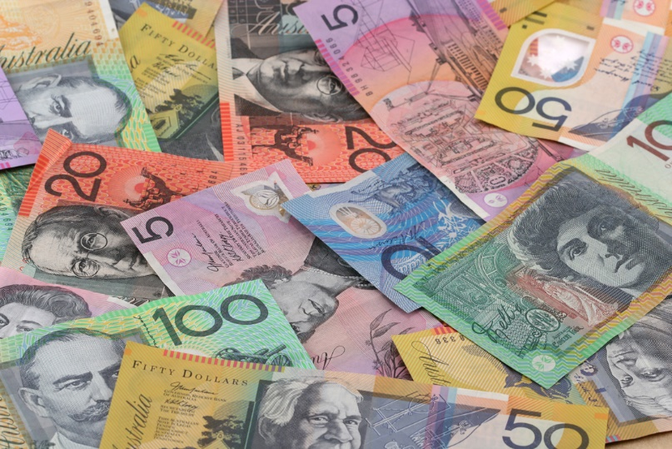**Different types of markets – Financial and Stock Markets**

**Financial markets**

Just as there are a number of markets for goods and services throughout the economy, there is also an important market for money. While households earn money in the form of wages and salaries, they will often choose to borrow money to buy larger items such as a car or a house. Businesses make money from selling goods and services to consumers, and generally try to make a **profit** by doing so. Sometimes part of that profit will be invested in expanding the business, but if the profits are not large enough to do this, the business may also want to borrow money to help it grow.

Figure 1 Money performs important functions in our economy.

**The functions of money -** Money performs four very important functions in our market system:

1. *Medium of exchange* – Money allows us to exchange goods and services using a common means of exchange we all accept. Employees exchange their labour for money, and all businesses accept money in exchange for the goods and services they supply.
2. *Measure of value* – We use money to put a price on the goods and services we exchange. The price is a measure of what we believe the goods or services to be worth, when compared with other goods and services.
3. *Store of value* – We are able to save our money to spend at a later date.
4. *Standard of deferred payments* – Using money allows us to purchase goods and services on credit, with both buyer and seller knowing how much has to be paid at a later date.

**The working of financial markets**

Just as all goods and services have a price, so too does money. The price of having access to money that actually belongs to someone else is known as **interest**. When you deposit your money in a bank account, the bank will pay you interest on your savings. This is usually based on a percentage figure. If you deposit $100 in your account, and the bank is paying three per cent per annum (per year), the bank will pay you three dollars in interest after a year. Interest is often calculated monthly or even daily, so that if you withdraw your money before the year is up, you will be paid a lesser amount to cover the time the bank had the use of your money. Banks then lend out the money that they have deposited with them to other consumers or to businesses. They will usually charge a higher rate of interest to borrowers than they pay to their depositors. This is how they make a profit.

If you have money to deposit, it is often worth shopping around to get the best rate of interest. Sometimes it is possible to earn a higher rate of interest if you undertake to leave the money in the bank for a fixed period of time. This is known as a *term deposit*, because the money is deposited for a fixed *term*, or period of time. When borrowing money you want to pay the lowest possible rate of interest, so it is also worthwhile to shop around a number of lenders to get the best deal.

Financial markets operate like any other market, with sellers wanting to charge the highest price they can for their goods and services, and buyers wanting to pay the lowest price they can. If you are selling the use of your money, that is, you are a depositor, you want to get the best price (interest earnings) you can for allowing someone else to use that money. If you are buying the use of someone else’s money, you want to pay the lowest price (interest payments) you can.

**Stock market**

Like other markets, the stock market is simply a relationship between buyers and sellers. In this case it is shares in companies that are bought and sold. A share is a unit of ownership in a company. Large companies divide their ownership into thousands of shares, which can be bought and sold through the stock market, known in Australia as the Australian Securities Exchange (ASX). The ASX was formed in 1987 by amalgamating the six capital-city stock exchanges. Today the ASX is based in Sydney, but has offices in Melbourne and Perth.

There are over 2000 companies listed on the ASX. They include large retailers such as Woolworths and Wesfarmers (owners of Coles); the four big banks – ANZ, CBA, NAB and Westpac; and large mining companies such as BHP Billiton and Rio Tinto. The value of shares can go up and down, depending on the demand for those shares. When a company reports that it has had a successful year, many people may want to buy shares in that company. If there are more people wanting to buy than to sell, the price tends to rise. If the company appears to not be performing well, there may be more shareholders wanting to sell their shares than there are buyers, so the price is likely to go down.

As the price of a company's shares goes up or down, so too does the value of a shareholder’s investment. The value of most shares has tended to rise over the past 50 years or so, even though they can fluctuate in price on a daily or weekly basis. People who hold shares for long periods of time generally benefit from **capital growth**. The ownership of shares means you can also benefit when the company makes a profit, as profits can be distributed to shareholders as **dividends** or in extra shares.

Figure 2 Stockbrokers buy and sell shares on behalf of their clients.

The buying and selling of shares is usually handled by stockbrokers. These are licensed agents who have access to the ASX, and who conduct share transactions on behalf of the general public in exchange for a small fee. Most stockbrokers will recommend that their clients buy shares in a variety of different companies. If you only buy shares in one company and that company experiences problems, the value of your shares can drop and you lose money. Buying shares in a number of different companies reduces the risk, and you have a better chance of having some shares that will perform well.

**Questions:**

1. **Explain what “Profit” is. What is it sometimes used to do?**
2. **List the four functions of money.**
3. **Describe what “Interest” is. How is it calculated?**
4. **How do banks make a profit using interest?**
5. **Explain “fixed term deposit”.**
6. **What is a share?**
7. **What is the ASX?**
8. **When did the ASX form?**
9. **List some of the large companies listed on the ASX.**
10. **What events cause prices of shares to rise?**
11. **Explain what “dividends” are.**
12. **Who are stockbrokers and what do they do?**
13. **How can people reduce the risks when buying shares?**
14. **Watch the Share market basics and then answer the following questions:**
    1. **What are you buying when you buy shares?**
    2. **What would be the situation if you owned 100 per cent of the shares in a company?**
    3. **What is the role of a stockbroker?**
    4. **When is the stock market report published?**